Lab 5- Acceleration Due to Gravity
Student’s Name
Institutional Affiliation

Abstract
The question on the whether the mass of the pendulum affects the period, depends on whether the pendulum is real or ideal. For ideal pendulum, mass of the bob does not affect the period. But for a real pendulum, the mas of the point mass do affect the period of the pendulum. In derivation of the time period of a simple pendulum, it is treading as an ideal pendulum which has the following conditions:
- The string that swings the bob is massless
- The mass of the pendulum is of point mass
- The motion of the pendulum only occurs in two dimensions
- There is no loss of energy
- Due to friction
- The gravitation field is uniform
- The effect of the rotation of the earth is ignored
- The support does not move

Experiment: determining the acceleration due to gravity, “g”, from the period of a pendulum
Aim:
- To investigate the effect of carrying mass on period
- To investigate the varying of length of the pendulum
- To calculate the acceleration due to gravity by observing the motion of pendulum
Introduction
A simple pendulum is made up of point mass which is suspended from the string of length l with negligible mass. The forces that act on the bob include the force of the gravity and the tension from the string. A simple pendulum has small diameter bob and the string that has small mass is strong enough not to stretch appreciably.
The linear displacement from the equilibrium it is the act traced by the washer or bob. When the bob is displaced to an initial angle and released, the pendulum will swing back and forth with a periodic motion. The period depends on acceleration due to gravity as well as other factors. The period of pendulum does not depend on the mass and initial angular displacement. It only depends on the length L of the string and the gravitation field strength.
Theory
By applying the newton’s second law rotational system, the equation of the system of motion for the pendulum can be obtained.
-mg sin θ L= mL² (d²θ/dt²)
If the amplitude of the angular displacement is small enough that the small angle (sin θ = 0) holds true, then the equation of motion reduces to the equation of simple harmonic motion (Open & Urone, 2012).
(d²θ/dt²) + (g/L) θ = 0
Natural angular velocity (ω) = $\sqrt{g/L}$
With assumption of small angles, the frequency and period of pendulum are independent of the initial angular displacement amplitude. Simple pendulum should have same period regardless of the initial angle and mass.
T = 2𝜋$√\frac{l}{g}$ where g is the acceleration due to gravity at the surface of the earth
I can also be written as T² ⁼ 4𝜋²$\frac{l}{g}$
The equation can also be written as equation of straight line
T²=$\frac{4π^{2}}{g}l$ + 0
Where $\frac{4π^{2}}{g}$ is the gradient
Materials/equipment
- 1.5 meters of string
- 5 large washers
- 1 stop watch
- 1 meter stick
Procedure
Investigating the period and mass
- Construct a simple pendulum by tying a large washer to the string
- Measure the length L of the pendulum and record in the table of data
- Record the time for 10 oscillation of the pendulum
- For five different pendulum masses, find the period of the pendulum. Repeat the experiment for 5 times and record the data in the table of values
Table of data

Column1 | Hanging mass (kg) | Length L (m) | Time for 10 oscillations (s) | Time 1 oscillation (s) | Period squired (s²)
Trial 1 | 0.01 | 0.7 | 1 | 0.1 | 0.01
Trial 2 | 0.02 | 0.7 | 1.9 | 0.19 | 0.039
Trial 3 | 0.03 | 0.7 | 2.4 | 0.24 | 0.057
Trial 4 | 0.04 | 0.7 | 3.1 | 0.31 | 0.096
Trial 5 | 0.05 | 0.7 | 4 | 0.4 | 0.16

A graph of T versus mass

Investigating the period and length
- Construct a pendulum using two big washers to the string
- Construct the data table and repeat the experiment for five times
- Repeat the procedure above with different length L

Data table 2: trial values for string length for mass of washer o.25Kg

Length (m) | Trial 1(s) | Trial 2 (s) | Trial 3 (s) | Trial 4(s) | Average time (s) | Average T period (s) | T² | 4𝜋²L | g=((4𝜋²)(L))/T²
0.25 | 5.19 | 5.11 | 5.14 | 5.14 | 5.12 | 1.02 | 1.04 | 9.87 | 9.87
0.5 | 7.17 | 7.24 | 7.29 | 7.23 | 7.33 | 1.41 | 1.988 | 19.74 | 9.92
0.75 | 8.67 | 9.01 | 8.88 | 8.85 | 8.75 | 1.75 | 3.063 | 29.61 | 9.66
1 | 10.04 | 10.1 | 10.04 | 10.06 | 10.05 | 2.01 | 4.04 | 39.49 | 9.77

Results and discussion
The graph of 4𝜋²L the vertical axis and T²
The slope = Δy/Δx
A graph of period of pendulum verses length

Is it linear?
The graph is not linear but it looks like a curve that is almost linear as seen in the graph. Majority of the majority of the point does not fall on the line. The graph does not originate from the origin. To obtain the best relationship between the variables the graph needs to be linearized (Atkins & Escudier, 2013). To linearize the graph, squired period is drawn on y-axis and the length of pendulum on x-axis. The modified graph will display a straight line with y axis close to zero.
The formula to determine the period is
T = 2𝜋$√\frac{l}{g}$ where g is the acceleration due to gravity at the surface of the earth
I can also be written as T² ⁼ 4𝜋²$\frac{l}{g}$
The equation can also be written as equation of straight line
T²=$\frac{4π^{2}}{g}l$ + 0
Where $\frac{4π^{2}}{g}$ is the gradient
Since the equation has a gradient, hence the relationship between the period and the length are must linear.
Percentage error
G = ((4𝜋²) (L))/T²
The accepted value of g is 9.81m/s²
We can calculate the value of the gravity from the experiment to determine the how accurate are our data. By using the formula g = ((4𝜋²)(L))/T², value are indicated in the table 2
The average gravitation force from the results
(9.87 + 9.92+9.66+9.77)/4 = 9.85m/s²
% error = [(9.85-9.81)/9.81] x 100 =0.4%
Possible sources of errors
- Errors have been caused by combination human and systematic errors
- Errors due to estimate of time
- Errors due to errors in measurement of length of string
Experiment 2
Procedure
1. Using a scissor, carefully and safely cut a rubber band so that it is becomes a single length of rubber and not a band.
2. Tie a string to one end of the rubber band.
3. Hold the rubber band vertically with the string end down and measure the length of the rubber band (not including the string).
4. Repeat your measurement 3 times.
5. Calculate the standard deviation of the length.
6. Create a data table with two columns. Column one should be labeled # of washers and column two should be labeled Displacement (m).
7. Tie two washers to the string and measure the new length of the rubber band. 8. Repeat #7, two washers at a time, until all 12 washers are used. Enter your data in the data table
Data table 3
Number of washers | Displacement (m)
0 | 0
1 | 0.01
2 | 0.002
3 | 0.005
4 | 0.006
5 | 0.007
6 | 0.009
7 | 0.01
8 | 0.012
9 | 0.015
10 | 0.016
11 | 0.017
12 | 0.019

Graph of number of washes vs displacement
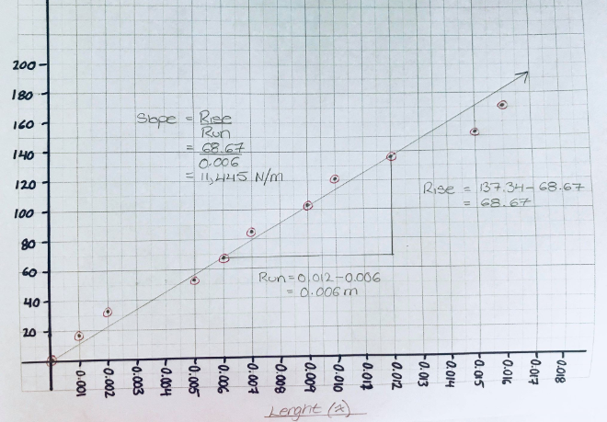

References
Atkins, A. G., & Escudier, M. P. (2013). A dictionary of mechanical engineering.
Open, S., Urone, P. P., & OpenStax College,. (2012). College physics.

